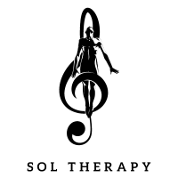
Sound healing has accompanied humanity since prehistoric times, from tribal drumming ceremonies in Africa to Tibetan singing bowls, right up to our present day. Each generation has refined and expanded the use of sound for the healing of body and mind.
In our "Sol Therapy" events series, we invite those at the cutting edge of the musical world - leading DJs and electronic music creators - individuals who have dedicated their adult lives to endlessly digging through record crates, countless hours in studios mastering the technical aspects of sound to fine-tune frequencies and then applying this entire process to captivate audiences of thousands in clubs and festivals around the globe.
The music they create and curate effortlessly transcends language and cultural barriers, taking large audiences on fascinating journeys of consciousness alteration and, in some cases, a true spiritual voyage. In the workshop, we will invite leading creators for intimate sessions - lying down sound meditations, where they guide us through deep and intriguing sessions.
List of Artists Already Hosted: Red Axes, Omri Smadar, Biri, Ran Slavin.
List of Artists of future planned artists: Daniel Avery, Donato Dozzy, Juan Atkins, Damian Lazarus, Craig Richards, Moritz von Oswald, Biosphere, Ben Klock, Ivan Smagghe, DJ Nobu, Carl Craig, Francesco Tristano, Barker.

